Case 2-AFR-EGY-Ushabti-30th Dynasty-381-343 BCE

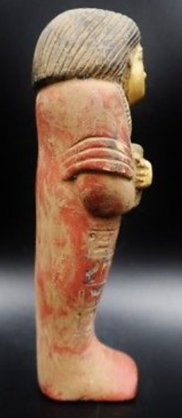 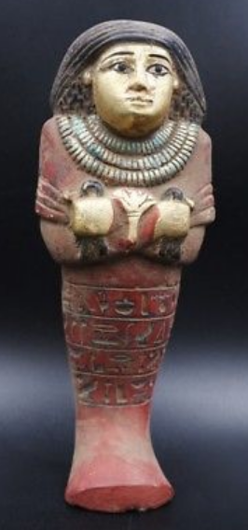 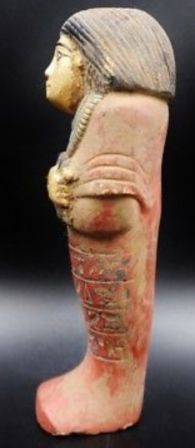

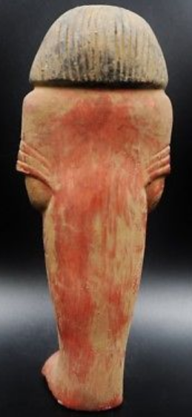

.

**Case No.: 2**

**Accession No.**

**Formal Label:** Ushabti-30th Dynasty-381-343 BCE

**Display Description:**

The 30th Dynasty was founded by [Nectanebo I](https://en.wikipedia.org/wiki/Nectanebo_I), son of a military official named Teos (*not* his own son and successor), and himself a prominent general, he deposed and likely killed Nefaarud II, father of Teos. The elder Nectanebo moved the capital of Egypt from [Mendes](https://en.wikipedia.org/wiki/Mendes) to Sebennytos.[[2]](https://en.wikipedia.org/wiki/Thirtieth_Dynasty_of_Egypt#cite_note-Mark_2016-2) He also engaged in many building projects across Egypt, perhaps outdoing many of his predecessors; Nectanebo is credited with beginning the construction of the Temple of [Isis](https://en.wikipedia.org/wiki/Isis) at [Philae](https://en.wikipedia.org/wiki/Philae), among other things.[[3]](https://en.wikipedia.org/wiki/Thirtieth_Dynasty_of_Egypt#cite_note-3) He respected religion and attempted to bring Egypt closer to the gods by restoring monuments and giving them gifts, as well as defended Egypt from the aggressive [Achaemenid Empire](https://en.wikipedia.org/wiki/Achaemenid_Empire).[[](https://en.wikipedia.org/wiki/Thirtieth_Dynasty_of_Egypt#cite_note-4) and was disestablished upon the invasion of Egypt by the [Shah](https://en.wikipedia.org/wiki/Shah) of Persia, [Artaxerxes III](https://en.wikipedia.org/wiki/Artaxerxes_III) in 343 BC. This is the final native dynasty of ancient Egypt; after the deposition of [Nectanebo II](https://en.wikipedia.org/wiki/Nectanebo_II), Egypt entered under foreign domination.

**Accession Number:**

**LC Classification:**

**Date or Time Horizon:**

**Geographical Area:**

**Map:**

**GPS coordinates:** [30°58′00.0″N 31°15′00.0″E](https://tools.wmflabs.org/geohack/geohack.php?pagename=Sebennytos&params=30_58_00.0_N_31_15_00.0_E_type:landmark)

**Cultural Affiliation:**

**Media:**

**Dimensions:** 17 x 7 x 4.5 cm; 6.7 in x 2.75 in x 1.8 in

**Weight: 455 gm**

**Condition:**

**Provenance:**

**Discussion:**

**References:**